PAP Algebra 2 Name: __________________________
HW: System Applications
For #1-2, solve each system of two equations in two variables by hand using substitution.

1. 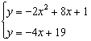 2. $y=x^{2}-7$ and $2x+y=8$

For #3-6, solve each system by matrices.
3. $\left\{\begin{aligned}2x-3y=7 \\ y+z=-5 \\ x+2y+4z=-17\end{aligned}\right.$ 4. $\left\{\begin{aligned}5x+y+3z=9 \\ -x-2y-z=-16 \\ 2x+4y+2z=-30\end{aligned}\right.$

5. $\left\{\begin{aligned}x-4y+3z=-7 \\ 2x+3y-5z=19 \\ 4x+y-z=17\end{aligned}\right.$ 6. $\left\{\begin{aligned}2x-3z=4 \\ 2x+y-5z=-1 \\ 3y-4z=2\end{aligned}\right.$

Turn over for more
For #7, formulate a system of equations for each word problem and solve using matrices.
7. Your school’s Key Club decided to sell fruit baskets to raise money for a local charity. The club sold a total of 80 fruit baskets. There were three different types of fruit baskets. Small fruit baskets sold for $15.75 each, medium fruit baskets sold for $25 each, and large fruit baskets sold for $32.50 each. The Key Club took in a total of $2086.25, and they sold twice as many large baskets as small baskets. How many of each type of basket were sold?

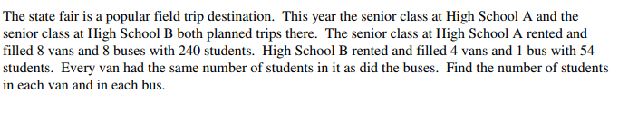
For #8, formulate a system of equations for each word problem and solve by hand.
8.

