**Special Cases of System of Equations**

**Solve using substitution or elimination.**



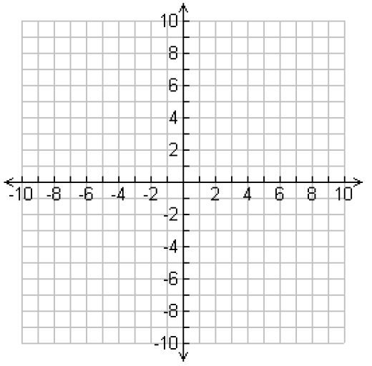**Try graphing method:**

**Solve using substitution or elimination.**



**Try graphing method:**

Two Variable Systems- Quadratic & Linear

Can you sketch a system of a Quadratic graph and a Linear graph with…

2 Solutions 1 Solution

Infinite solutions No Solutions

Solve by hand using substitution method.

EX 1. 

EX 2.



EX 3.

