Name ______________________________________________ Solving systems HW

The school band decides to sell chocolate bars to raise money for an upcoming trip. The cost and the revenue of selling the candy bars are represented on the graph below.

Candy Bar Sales

200

150

100

50

0

Dollars

0 50 100 150 200 250 300

Number of Bars Sold

Cost

Revenue

1. At what point do the two graphs intersect?

2. What would be the approximate revenue from selling 50 candy bars?

3. What would be the approximate revenue be from selling 125 candy bars?

4. How many candy bars must the band sell for the revenue to be $200? How much of this revenue would be profit?

Graph the following lines to find where they intersect each other.

Show all your work needed.



5. 

# Answer: ___________

The new movie theater opened in Regal’s neighborhood. The theater offers a yearly membership for which customers pay a fee of $50, after which they pay only $1 per movie. Nonmembers pay $4.50 per movie. Regal is trying to figure out whether to buy a membership. She writes these cost equations.

6. Write a system of equations to represent the cost for a member and the cost for a nonmember.

7. If Regal sees ten movies this year, what would be her cost under each plan?

8. How many movies must Regal see this year to make the yearly membership a better deal?

9. What does the coefficient of *n* in each equation tell you about the situation?

**Write and Solve the system of equations for each problem using either substitution or elimination . Show all work on your own paper**.

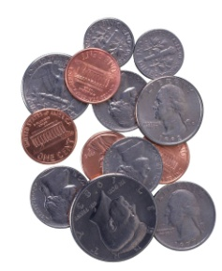10. You have 12 coins in quarters and dimes. If your coins total $1.95, how many of each do you have?

11. An art class is planning a trip to a museum. There are 22 people on the trip. There are 4 drivers and 2 types of vehicles, vans and cars. The vans seat 6 people and the cars seat 4 people, including drivers. How many vans and cars does the class need for the trip?

MC900310664[1]

12. A will states that John is to get 3 times as much money as Mary. The total amount they will receive is $11,000. How much will each get?

13. The width of a patio is 5 feet less than twice its length. The difference between the length and width is 1 foot. Find the dimensions of the patio.

14. To furnish a school cafeteria a school can spend $5200 on tables and chairs. Tables cost $200.00 each and chairs cost $40.00. There are 8 times as many chairs as tables. How many tables and chairs will the school purchase for the cafeteria?