**10.3 Explore /explain Square and Cube Root Transformations**

**Quadratic & Square Root Functions**

** **

|  |  |
| --- | --- |
| **X** | **Y** |
| -2 |  |
| -1 |  |
| 0 |  |
| 1 |  |
| 2 |  |
| 3 |  |

|  |  |
| --- | --- |
| **X** | **Y** |
| -4 |  |
| -1 |  |
| 0 |  |
| 1 |  |
| 4 |  |
| 9 |  |

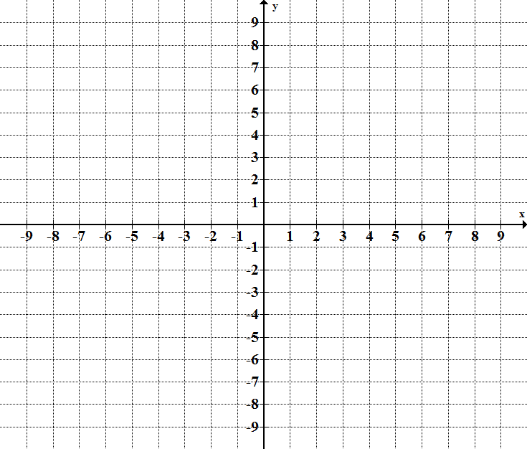

Domain: _________ Range:__________

x-int: _________ y-int:___________

min:____________ max:____________

Domain: ________ Range:__________

x-int: __________ y-int:___________

min:_____________ max:___________

Why do you think the table gives you an error for a y value for ****?

**For the following list the transformations compared to the parent function, find the domain, range, maximum, and minimum. Sketch if needed.**

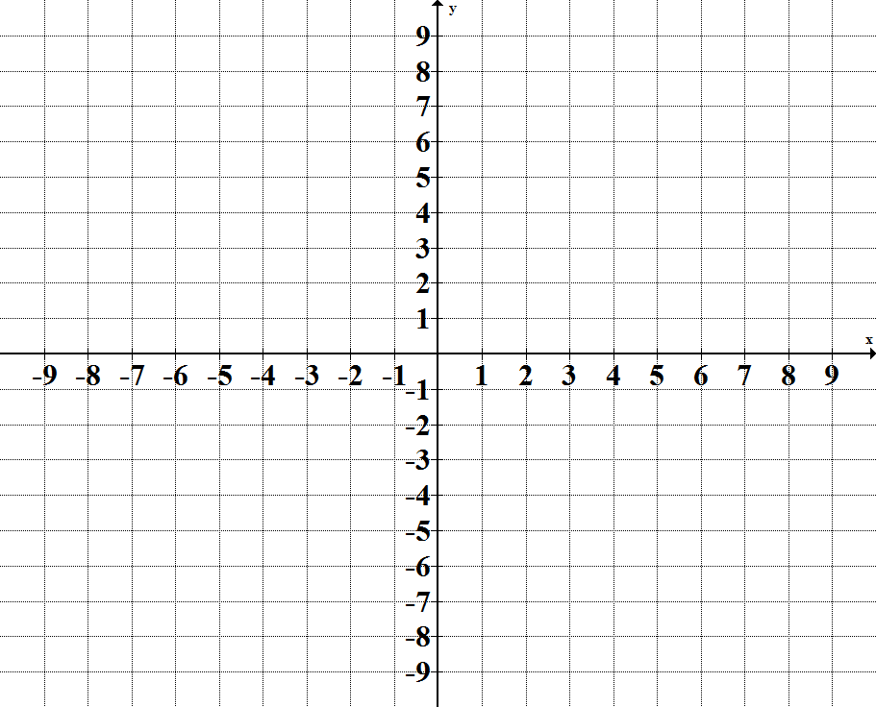1) 

List transformations:

Domain: Maximum:

Range: Minimum:

2)



List transformations:

Domain: Maximum:

Range: Minimum:

3)

List transformations:

Domain: Maximum:

Range: Minimum:

**For the following functions find . Note domain restrictions.**

4)  5) 

**Cube & Cube Root Functions**

** **

|  |  |
| --- | --- |
| **X** | **Y** |
| -2 |  |
| -1 |  |
| 0 |  |
| 1 |  |
| 2 |  |

|  |  |
| --- | --- |
| **X** | **Y** |
| -8 |  |
| -1 |  |
| 0 |  |
| 1 |  |
| 8 |  |



Domain: __________ Range:________

x-int: __________ y-int:________

min:_____________ max:__________

Domain: __________ Range:________

x-int: __________ y-int:________

min:_____________ max:__________

**For the following list the transformations compared to the parent function, find the domain, range, maximum, and minimum. Sketch if needed.**



1)

List transformations:

Domain: Maximum:

Range: Minimum:



2)

List transformations:

Domain: Maximum:

Range: Minimum:



3)

List transformations:

Domain: Maximum:

Range: Minimum

**For the following functions find . Note domain restrictions.**

4)  5) 

**Compositions of Functions Notes**

**FUNCTION PROPERTIES:**

Given functions  and  the following properties hold true:

COMPOSITION: 

To compose two functions means to make the output of one function the input of another function.

1. 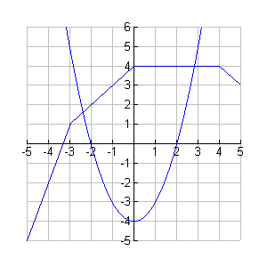Given the following graph of f(x) and g(x) find the following:

f(x)

* 1. 
  2. 

g(x)

* 1. 
  2. 
  3. 

1. Given the functions , , , and  find:

**a) = b)  c) **

**d)** f(3) = **e)** g(-3) = **f)** g(5) =

**g)** g(h(1))= **h)** h(f(-1))= **i)** j(h(2)) =

**j)  k)  l) **