PAP Algebra 2 Name: _______________________________
3.2-3.4 Practice WS
Given complete the table and graph h(x).

1. 2.
Reference Points of f(x) |  | Corresponding Points on h(x)
(0, 0)
(1, 1)
(2, 4)
Reference Points of f(x) |  | Corresponding Points on h(x)
(0, 0)
(1, 1)
(2, 4)

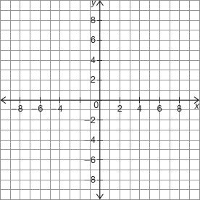

Each given function is in transformational function form where Identify the values of C and D for the given function. Then, describe how the vertex of the given function compares to the vertex of f(x).

3. 4.

Graph each vertical dilation of accurately, and tell whether the transformation is a vertical stretch or a vertical compression and if the graph includes a reflection.

5. 6. 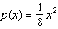
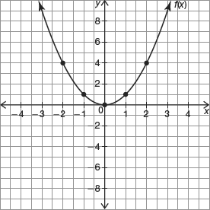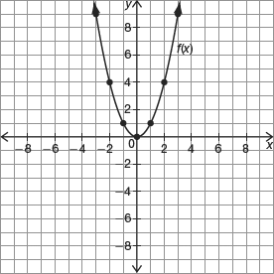

7. 8. 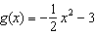
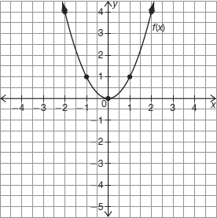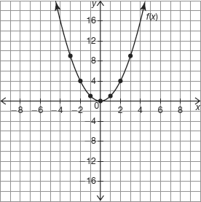

Each given function is in transformational function form where Describe how g(x) compares to f(x). Then, use coordinate notation to represent how the A-, C-, and D-values transform f(x) to generate g(x).

9. 10.

11.

11. 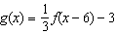 12. 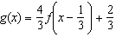

Write the transformations that occurred from $f\left(x\right)=x^{2}$ to the given graphs below in function notation.

13. a = 2 14. a = 1
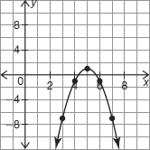
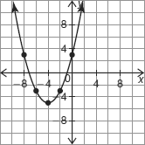

Write a function $g(x)$ that has been transformed from $f\left(x\right)=x^{2}$ in function notation using the characteristics below.

15. Vertically compressed 16. Horizontally reflected

17. Horizontally stretched 18. Vertically stretched

19. Vertically reflected 20. Horizontally compressed

The graph of f(x) is shown. Sketch the graph of the given transformed function.

21. $t\left(x\right)=-f(x-4)$ 22. $r\left(x\right)=f\left(\frac{1}{2}\left(x+2\right)\right)+2$

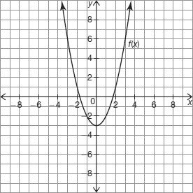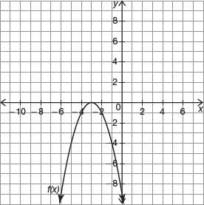

23. $d\left(x\right)=f(-x)$

