Move the Monster
Pre-AP Algebra 2 Name____________________________
Given:

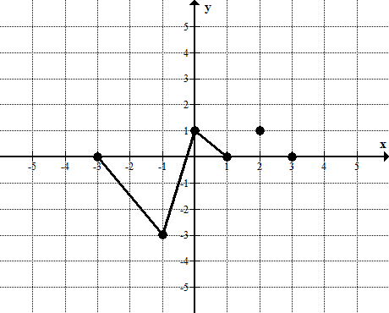
x | y
-3 | 0
-1 | -3
0 | 1
1 | 0
2 | 1
3 | 0

Using the above table and graph, complete the following transformations by graphing the transformed function, filling out the table, giving an explanation of the transformation, and listing the domain and range.

- g(x) = h(x) + 2
Graph: g(x) Explanation:
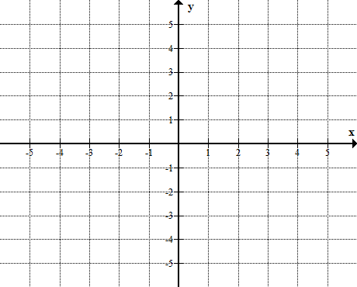
Write a verbal description of the transformation of h(x).

Domain:

Range:
New  x | Original  x | Original  y | New  y
 | -3 | 0
 | -1 | -3
 | 0 | 1
 | 1 | 0
 | 2 | 1
 | 3 | 0

- g(x) = h(x) – 2
Explanation:
Write a verbal description of the transformation of h(x).

Domain:

Range:

New  x | Original  x | Original  y | New  y
 | -3 | 0
 | -1 | -3
 | 0 | 1
 | 1 | 0
 | 2 | 1
 | 3 | 0
Graph: g(x)

- g(x) = h(x + 2)

Graph: g(x)
Write a verbal description of the transformation of h(x).

Domain:

Range:
New  x | Original  x | Original  y | New  y
 | -3 | 0
 | -1 | -3
 | 0 | 1
 | 1 | 0
 | 2 | 1
 | 3 | 0

- g(x) = h(x – 2)

Graph: g(x) Table: g(x)
Write a verbal description of the transformation of h(x).

Domain:

Range:
New  x | Original  x | Original  y | New  y
 | -3 | 0
 | -1 | -3
 | 0 | 1
 | 1 | 0
 | 2 | 1
 | 3 | 0

- g(x) = h(x – 1) + 3
Explanation:
Write a verbal description of the transformation of h(x).

Domain:

Range:
New  x | Original  x | Original  y | New  y
 | -3 | 0
 | -1 | -3
 | 0 | 1
 | 1 | 0
 | 2 | 1
 | 3 | 0
Graph: g(x)

- g(x) = – h(x)

Graph: g(x)
Write a verbal description of the transformation of h(x).

Domain:

Range:
New  x | Original  x | Original  y | New  y
 | -3 | 0
 | -1 | -3
 | 0 | 1
 | 1 | 0
 | 2 | 1
 | 3 | 0

- g(x) = h(- x)
Write a verbal description of the transformation of h(x).

Domain:

Range:

Graph: g(x)
New  x | Original  x | Original  y | New  y
 | -3 | 0
 | -1 | -3
 | 0 | 1
 | 1 | 0
 | 2 | 1
 | 3 | 0

8. g(x) = h(-(x+3))
Write a verbal description of the transformation of h(x).

Domain:

Range:

New  x | Original  x | Original  y | New  y
 | -3 | 0
 | -1 | -3
 | 0 | 1
 | 1 | 0
 | 2 | 1
 | 3 | 0
Graph: g(x)

9. g(x) = 2h(x)
Write a verbal description of the transformation of h(x).

Domain:

Range:
New  x | Original  x | Original  y | New  y
 | -3 | 0
 | -1 | -3
 | 0 | 1
 | 1 | 0
 | 2 | 1
 | 3 | 0
Graph: g(x)

10. g(x) =
Graph: g(x)
Write a verbal description of the transformation of h(x).

Domain:

Range:

New  x | Original  x | Original  y | New  y
 | -3 | 0
 | -1 | -3
 | 0 | 1
 | 1 | 0
 | 2 | 1
 | 3 | 0

11. g(x) = h(2x)

Graph: g(x)
Write a verbal description of the transformation of h(x).

Domain:

Range:
New  x | Original  x | Original  y | New  y
 | -3 | 0
 | -1 | -3
 | 0 | 1
 | 1 | 0
 | 2 | 1
 | 3 | 0

12. g(x) =$h(\frac{1}{2}x)$
Graph: g(x)

Write a verbal description of the transformation of h(x).

Domain:

Range:
New  x | Original  x | Original  y | New  y
 | -3 | 0
 | -1 | -3
 | 0 | 1
 | 1 | 0
 | 2 | 1
 | 3 | 0

Verbal Description Word Bank

Vertical shift up
Vertical shift down
Vertical stretch
Vertical compression
Vertical reflection (over x-axis)
Horizontal shift left
Horizontal shift right
Horizontal stretch
Horizontal compression
Horizontal reflection (over y-axis)

