PAP Algebra II Name:________________________

**Homework: Square & Cube Root Transformations & Intro to Compositions**

**For the given function equations find the following information. Make a sketch if necessary.**

1. 

Transformations:

Domain:

Range:

Max value:

Min value:

1. 

Transformations:

Domain:

Range:

Max value:

Min value:

1. 

Transformations:

Domain:

Range:

Max value:

Min value:

1. Write an equation using the square root parent function with a minimum value of -3
2. Write an equation using the square root parent function with a maximum value of 4
3. Write an equation using the parent function  that has a domain of  and a range of .
4. Write an equation where the parent function  has been shifted to the left 3, shifted down 3 and vertically stretched.

**Write an equation from the graph. State the domain & range of the function. Assume a = 1**.

1. 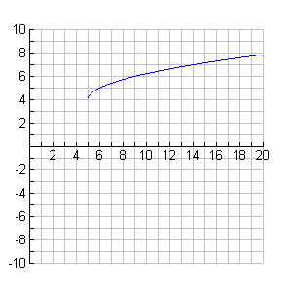

Equation:

Domain:

Range:

1. 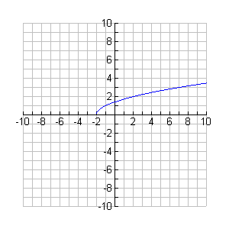Equation:

Domain:

Range:

**For the following functions find . Note domain restrictions.**

1. 
2. 
3. 
4. 
5. Given the functions , ,  and  find:

a)  b)  c) 

d)  e)  f) 

g)  h) 

1. Given the following graphs of f(x) and g(x) find the following:

**a)  b) **

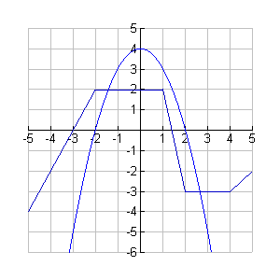

f(x)

g(x)

**c)  d) **

**e)  f) **