**PAP Algebra 2: 12.1 Notes**

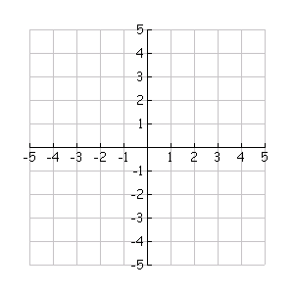**Exponentials and Logarithms as Inverses**

1. Graph the Exponential Function:

|  |  |  |  |
| --- | --- | --- | --- |
|  | *x* | y |  |
|  | -1 |  |  |
|  | 0 |  |  |
|  | 1 |  |  |

1. **Graph the Inverse of the function above in a different color.**
2. **Determine the equation for the inverse.**

**Steps:**

1. Switch x & y. 2. Isolate Exponential. 3. Convert to Logarithm. 4. Solve for y.

**Find the Inverse function of the following Exponential functions.**

1.  2. 

3.  4. 

**Find the Inverse function of the following Logarithmic functions.**

**Steps:**

1. Switch x & y. 2. Isolate Logarithm. 3. Convert to Exponential. 4. Solve for y.

5.  6. 

7.  7. 