**MCj02395470000[1]MCj02395470000[1]11.4 Explore: Logarithms**

1. Complete the table below for the function f(x) = 10x. Then, reverse the coordinates and enter them in Table 2.

**Table 1:** **Table 2:**

|  |  |
| --- | --- |
| x | f(x) |
| -2 |  |
| -1 |  |
| 0 |  |
| 1 |  |
| 2 |  |
| 3 |  |

|  |  |
| --- | --- |
| x | g(x) |
|  |  |
|  |  |
|  |  |
|  |  |
|  |  |
|  |  |

Plot the points from each table on the graph below and extend the graph. Plot Table 1 in blue, and plot Table 2 in red. Finally, draw in the dotted line y = x in green.

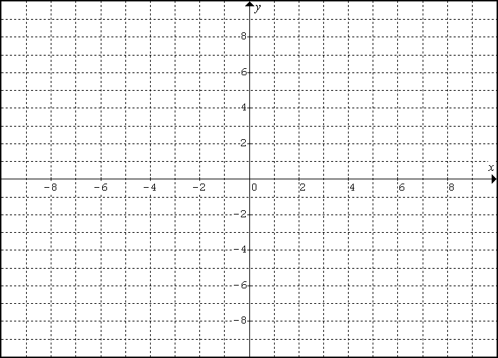

**f(x)**-**Blue Graph: g(x)**-**Red Graph:**

Domain: ________ Domain: ________

Range: _________ Range: _________

Asymptote:______ Asymptote:______

Intercept:________ Intercept:________

**What is the relationship between the blue graph and the red graph?**

2. Complete the table below for the function f(x) = ex. Then, reverse the coordinates and enter them in Table 2.

**Table 1:** **Table 2:**

|  |  |
| --- | --- |
| x | g(x) |
|  |  |
|  |  |
|  |  |
|  |  |
|  |  |
|  |  |

|  |  |
| --- | --- |
| x | f(x) |
| -2 |  |
| -1 |  |
| 0 |  |
| 1 |  |
| 2 |  |
| 3 |  |

Plot the points from each table on the graph below and extend the graph. Plot Table 1 in blue, and plot Table 2 in red. Finally, draw in the dotted line y = x in green.



**f(x)**-**Blue Graph: g(x)**-**Red Graph:**

Domain: ________ Domain: ________

Range: _________ Range: _________

Asymptote:______ Asymptote:______

Intercept:________ Intercept:________

**What is the relationship between the blue graph and the red graph?**

* The inverse of an exponential function is a ________________________ function.
* Exponential to Log example:  🡪 
* If no base is given for log(x), it is assumed to be ______________.
* If no base is given for ln(x), it is assumed to be _______________.