The inverse is a _____________________ of a graph over the line _____________.

So, to take the inverse, we __________ the x- and y-values or the domain and range.

1. Sharon recorded some data from children in the DFW area on how their age in years compared to how far they hit a golf ball in m. She was thinking that the distance depended on the age. Graph the data. (hint: count by 2.5)

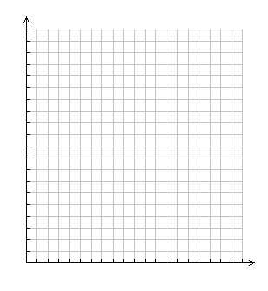

|  |  |
| --- | --- |
| Age | Distance |
| 1 | 1 |
| 2 | 4 |
| 3 | 9 |
| 4 | 16 |
| 5 | 25 |
| 6 | 36 |
| 7 | 49 |

a. What is the domain of Sharon’s graph?

b. What is the range?

1. Kenny thought that the age depended on the distance. He took Sharon’s data and changed it so that the x-value represents the distance and the y-value represents the age. Graph this data on the same grid, but in a different color.

a. What is the domain of Kenny’s graph?

b. What is the range?

1. What kind of relationship exists between Sharon’s and Kenny’s way of looking at the data?
2. Over what line is the graph of the data reflected? Graph this line in a third color.

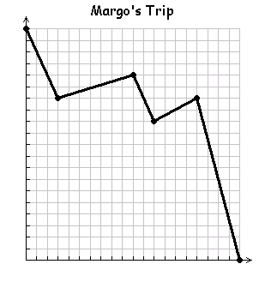

Rick’s Trip

1. The following graph represents Rick’s trip home from a friend’s house with distance from home in terms of time. Deborah thinks that it should be time in terms of distance. Plot Deborah’s graph on the same plane. What is the relationship between these two graphs?

Rick’s Key Points:

Deborah’s Key Points:

6) What is the difference in looking at the situation from Rick’s perspective as opposed to Deborah’s perspective?

1. Is Rick’s graph a function? Is Deborah’s graph a function?
2. Does Rick’s graph pass the vertical line test? Does his graph pass the horizontal

line test?

1. If a graph passes the horizontal line test, will its inverse be a function?

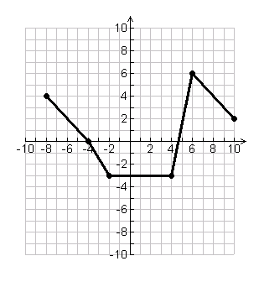10) What does it mean if the graph does not pass the horizontal line test?

11) Graph the inverse of this function;

graph the line of reflection as well.

Key Points:

Inverse Key Points:

12) Is the inverse a function? Justify your answer.