**11.5 Graphing Transformation of Log Functions** Name ____________________

**PAP Algebra 2**

**Example 1** Graph .

First get three points on the inverse.

Inverse Equation:

Domain: ______________

|  |  |
| --- | --- |
| **x** | **y** |
| -1 |  |
| 0 |  |
| 1 |  |

Range: _______________

HA: _________________

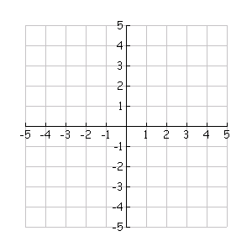Now, using the fact that logs are inverses of exponential functions, create a table for and graph.

|  |  |
| --- | --- |
| **x** | **y** |
|  |  |
|  |  |
|  |  |

Exponential functions have a horizontal asymptote; therefore, a log function should have a __________ asymptote. Make sure to include the asymptote, as a dotted/dashed line, on all your log graphs.

VA: _______________ Domain: _____________ Range: ____________

**Example 2** Graph .

First, note the transformations of ? ____________________________

Step 1: Make a table of values for y = 

Step 2: Make a table of values for *y* = log3*x*.

Step 3: Make a table of values for *y* =3 log3*x* + 2

Step 4: Graph the shifted equation.

|  |  |
| --- | --- |
| **x** | **y** |
| -1 |  |
| 0 |  |
| 1 |  |

|  |  |
| --- | --- |
| **x** | **y** |
|  |  |
|  |  |
|  |  |

|  |  |
| --- | --- |
| **x** | **y** |
|  |  |
|  |  |
|  |  |

VA: _______________ Domain: _____________ Range: ____________

a) Did the vertical asymptote move from the parent function? Why or why not?

**3)** Graph *y* = log4(x + 2)-3.

Step 1: Make a table of values for y = ___________

****Step 2: Make a table of values for *y* = ___________

Step 3: Make a table of values for *y* = ___________

Step 4: Graph the shifted equation.

Transformations:

|  |  |
| --- | --- |
| **x** | **y** |
| -1 |  |
| 0 |  |
| 1 |  |

|  |  |
| --- | --- |
| **x** | **y** |
|  |  |
|  |  |
|  |  |

|  |  |
| --- | --- |
| **x** | **y** |
|  |  |
|  |  |
|  |  |

VA: _______________ Domain: _____________ Range: ____________

a) Did the vertical asymptote move from the parent function? Why or why not?

**4)** Given y=  **5)** Given y= 

Transformations: Transformations:

VA: VA:

Domain: Domain:

Range: Range:

**6)** Given y*= * **7)** Given *y= *

Transformations: Transformations:

VA: VA:

Domain: Domain:

Range: Range: