PAP Algebra 2
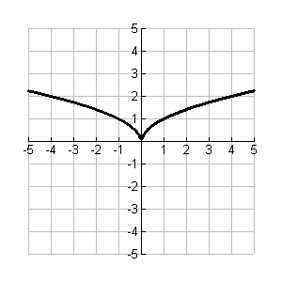
Evaluate:

Given the function f(x) as shown in the graph:
Critical Point:

Describe the transformation from f(x) to g(x) and write the rule for the function g(x) as a transformation of f(x).
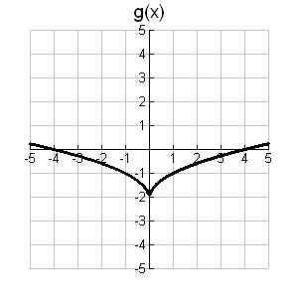
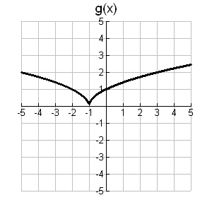
1. 2.

Trans. (verbal): Trans. (verbal):

Trans. (function notation): g(x) = Trans. (function notation): g(x) =

Domain: Domain:

Range: Range:

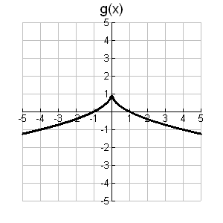
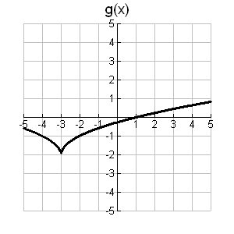
3. 4.

Trans. (verbal): Trans. (verbal):

Trans. (function notation): g(x) = Trans. (function notation): g(x) =

Domain: Domain:

Range: Range:

