Name_________________________________________________3.1 HW - Pre AP Algebra 2

Problem Set

Circle the function that matches each graph. Explain your reasoning.

1. 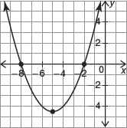

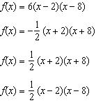

3. 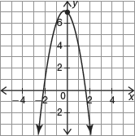

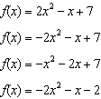

2. 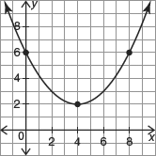

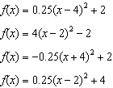

4. 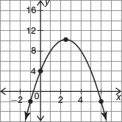

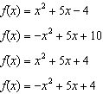
Convert each quadratic function in factored form to standard form.

5.

Convert each quadratic function in vertex form to standard form.

6.

Complete the table below by converting the given quadratic function into its other two forms.

7.
Standard Form | Vertex Form | Factored Form

8.
Standard Form | Vertex Form | Factored Form

