**Equation form of an Exponential Function:**

**y = a(b)x OR y = a•bx**

**a** = ­­­­­­­­­­­­­­­­­_____________________ **b** = ______________________ **x** = ______________________

**What is the difference between exponential growth and exponential decay?**

**Exponential Growth Graph** **Exponential Decay Graph**

Domain: Domain:

Range: Range:

H. Asymptote: H. Asymptote:

Critical Point: Critical Point:

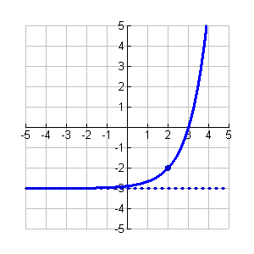

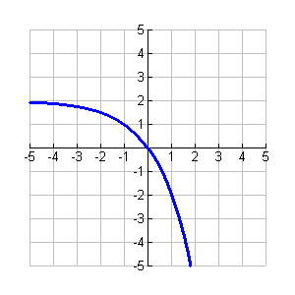

Domain:

Range:

Asymptote:

Domain:

Range:

Asymptote:

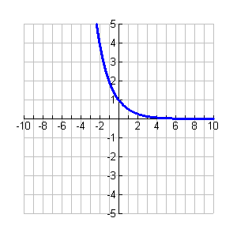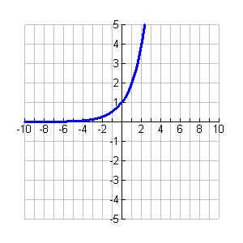

Domain:

Range:

Asymptote:

Domain:

Range:

Asymptote:

**Summary**

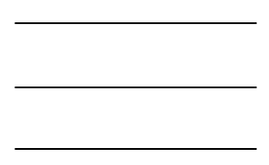 _____________ _____________







**Transformations of Exponentials**

**Explain**

Explain the transformations which will take place in each of the situations, state the domain and range AND show how each equation would be input into the calculator.

|  |  |  |
| --- | --- | --- |
| **1.**  Growth/Decay:  Transformations:  Critical Point:  Asymptote:  Domain:  Range: | **2.**  Growth/Decay:  Transformations:  Critical Point:  Asymptote:  Domain:  Range: | 5.  Growth/Decay:  Transformations:  Critical Point:  Asymptote:  Domain:  Range: |
| **6.**  Growth/Decay:  Transformations:  Critical Point:  Asymptote:  Domain:  Range: | 9.  Growth/Decay:  Transformations:  Critical Point:  Asymptote:  Domain:  Range: | 11.  Growth/Decay:  Transformations:  Critical Point:  Asymptote:  Domain:  Range: |
| **13.**  Transformations:  **left 3**  **down 4**  New function:  Critical Point:  Asymptote:  Domain:  Range: | 14. + 2  Transformations:  **reflect over x-axis**  **up 5**  New function:  Critical Point:  Asymptote:  Domain:  Range: | 15.  Transformations:  **right 4**  **up 2**  New function:  Critical Point:  Asymptote:  Domain:  Range: |